Midterm case

Group 6

1. Create Docker file, build all required environment, dependencies

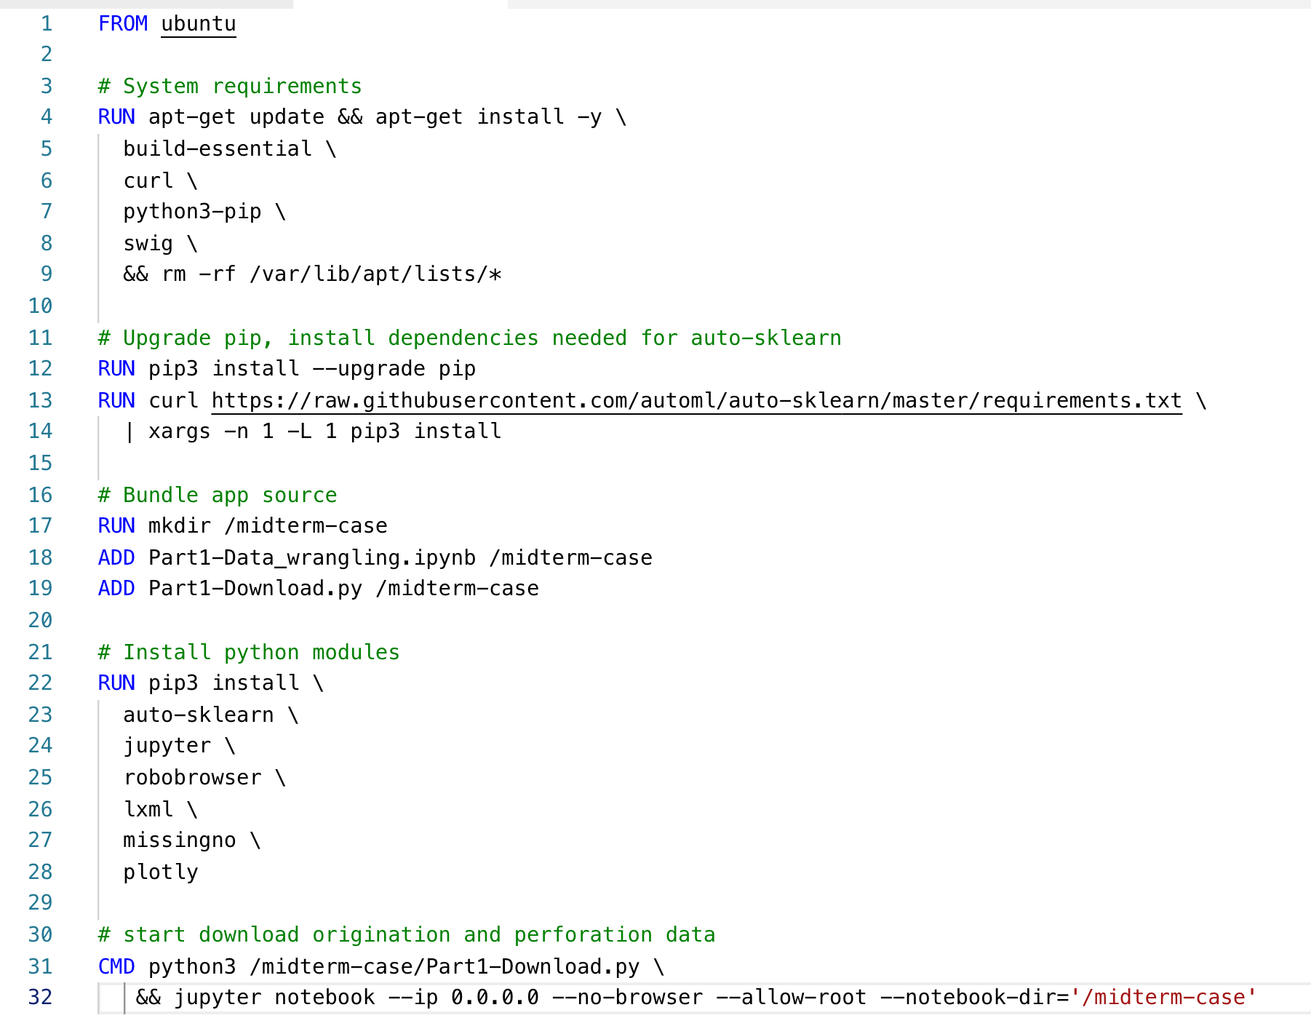

1. Build docker image

Come to the directory which have the Dockerfile

On terminal, run ‘docker build -t <tagname> . ’

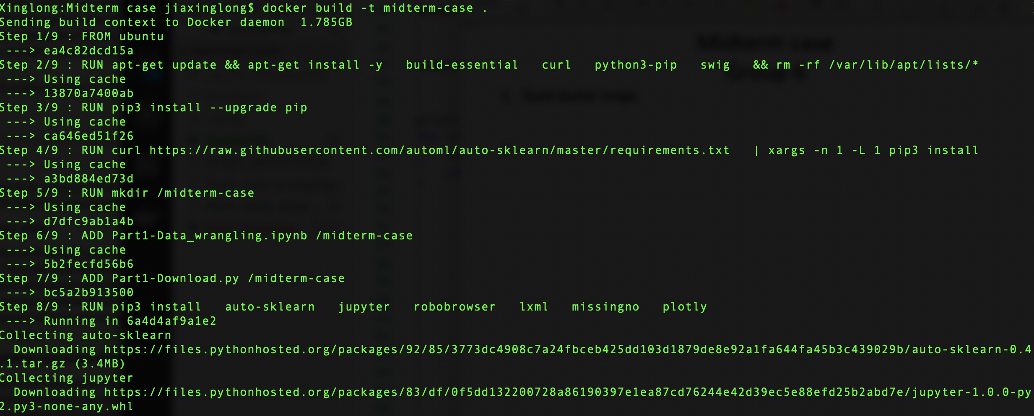

1. Run the image created, start the code

On terminal, run ‘docker run -ti -p 8888:8888 <tagname>:<version>’

